Management Information System 3
Ekurhuleni West TVET College faces with manual registration of students

Table of Contents
INTRODUCTION 3
1. PROBLEM IDENTIFICATION & SYSTEM ANALYSIS 3
2. EVALUATING THE CURRENT SYSTEM 4
3.8 HOW THE SYSTEM SUPPORTS TPS, MIS & DSS 9
4. DATABASE DESIGN 10
5. DATABASE IMPLEMENTATION 10
5.1. DATABASE CREATION 10
5.2 TABLE CREATION AND DATA INSERTION 11
Table Courses 11
Table Students 12
Table payments 13
Table financial_clearence 15
Table Registration 16
6. SQL Queries and Decision Support 18
6.1 Transaction Processing Queries 18
A1. Student Lookup 18
A2. Student Lookup 18
A3. Course Availability 19
A3. Registered Students 19
B. MANAGEMENT REPORTS 20
B1. Daily/Monthly clearance summary 20
B2. Monthly registration summary 21
B3 Outstanding clearance report 21
B4. Payment collection summary by method 22
B5. Monthly revenue analysis 22
B6. Course enrolment summary 23
C1. Registration trend 23
C2. Aggregated payment statistics 24
C3. Forecasting indicator - enrolment growth by week 25
C4. Bottleneck identification 25
C5. At-risk students report 26
7. SYSTEM EVALUATION AND RECOMMENDATIONS 26
BENEFITS 26
LIMITATIONS 27
RISKS 27
SECURITY CONSIDERATIONS 28
ETHICAL CONSIDERATIONS 28
FUTURE IMPROVEMENTS 29
RECOMMENDATIONS FOR IMPLEMENTATION 29
References 31

Table of Figures
Figure 1 Entity Relationship Diagram 10
Figure 2 Data Base Creation 11
Figure 3 Course tbl 12
Figure 4 Student tbl 13
Figure 5 Payment tbl 15
Figure 6 Financial Clearence 16
Figure 7 Registration tbl 17
Figure 8 Student Lookup 18
Figure 9 Student Lookup 19
Figure 10 Course Availability 19
Figure 11 Registered Students 20
Figure 12 Daily /monthly clearance summary 20
Figure 13 Monthly registration summary 21
Figure 14 Outstanding Clearance report 22
Figure 15 Payment collection summary by method 22
Figure 16 Monthly revenue analysis 23
Figure 17 Course enrolment summary 23
Figure 18 Registration trend 24
Figure 19 Aggregated payment statistics 24
Figure 20 Forecasting indicator - enrolment growth by week 25
Figure 21 Bottleneck identification 26
Figure 22 At-risk students report 26

INTRODUCTION
Information systems are fundamental to how modern organizations manage data, support operations, and make decisions. Organisations nowadays use Management Information Systems to integrate people, processes, and technology to provide timely and accurate information to managers at operational, tactical, and strategic levels.
This project looks at the problem that Ekurhuleni West TVET College faces with manual registration of students. We will also analyse the current system, evaluate its faults, and propose a database-driven MIS solution.

1. PROBLEM IDENTIFICATION & SYSTEM ANALYSIS
Ekurhuleni West TVET College operates six campuses across Ekurhuleni, with Germiston campus serving as the college's corporate centre. The college already has a student self-service portal where students can view their fee balances and academic information. However, the registration process itself is still manual, and it requires students to personally come to campus to register. Students must first obtain proof of payment from the bank or the EWC finance department to be financially cleared. Students can only go to the Registration department to register after being financially cleared. This whole process makes students stand in long queues for hours and possibly return the following day if a department is closed or busy.
1.1 WHY THE PROBLEM EXISTS
The problem exists because the EWC registration and financial clearance processes were never integrated into the existing student portal. The portal was designed only for viewing information not for processing transactions. The finance and registration departments also work in silos meaning each department is keeping its own records. Student financial status cannot be verified electronically by the registration office and in addition there is no digital workflow that links proof of payment, financial clearance and registration into one seamless process. Student numbers have grown and the manual process has become slower and more congested because EWC has not yet invested in an integrated online registration system.
1.2 STAKEHOLDERS AFFECTED
The primary stakeholders who are affected by the manual processes are the students, registration clerk, finance officer and the campus manager. The students are directly impacted because they must travel to campus, stand in long queues and must move between departments just to complete registration. The finance officer must manually verify each student’s proof of payment and clear them one by one, which is repetitive and time-consuming. The registration clerk can only register a student after the finance department has cleared them, this creates a congestion and delays. The campus manager is directly affected because the slow registration process damages the EWC’s reputation, reduces enrolment efficiency, and makes it difficult to plan staffing and resources during peak periods.
1.3 WHY INFORMATION MANAGEMENT IS IMPORTANT
Effective information management is essential at EWC because registration numbers directly influence funding and staffing decisions and inaccurate or delayed data can lead to poor planning. Financial clearance is also important because it affects the cash flow and financial sustainability of EWC, an error in verifying payments can result in financial loss. Correct student records are very important for certification and auditing as they ensure that qualifications are awarded correctly and EWC remains accountable. Timely records are also important because they support compliance with DHET and SETA requirements, which is necessary for EWC to maintain its accreditation and access to government funds.
1.4 CONSEQUENCES OF THE CURRENT SITUATION
The current situation creates several serious consequences for the EWC. Students face long registration queues and often wait long hours before getting help, and some are forced to return the next day. This cross-department process causes frustration and damages the college’s reputation. The staff is overworked during peak registration periods, and the manual verification of payments is slow and error-prone. Management has no real-time view of how many students have been unblocked or registered, which makes planning difficult. There is also a poor audit trail, which increases the risk of fraud, and students sometimes receive incorrect fee statements, which damages trust in the college.

2. EVALUATING THE CURRENT SYSTEM
The college currently uses a combination of a student self-service portal and manual, in-person processes to manage registration and financial clearance. The portal allows students to view their fee balance and module information, but it does not allow them to register or to be financially cleared. To register, a student must first obtain proof of payment or a paper slip from the bank or the finance office. They must then physically take this proof to the Finance Department, where a finance officer manually checks it and unblocks the student on the system. Only after being unblocked can the student go to the registration office, where a registration clerk manually registers them for their modules. This fragmented process means that registration cannot be completed without physically moving between departments, and each department keeps its own records.
2.2 STRENGTHS OF THE CURRENT SYSTEM
The current system does have some strengths. The student portal gives students basic visibility of their fee balance and academic information, which reduces some queries to staff. Staff are already familiar with the manual registration and clearance processes, so little training is required to keep them running. The software cost is low because the portal and Excel are already available, meaning no additional licensing fees are needed. The system is also flexible enough to handle small volumes of students, and it does not depend on a fully integrated digital workflow, so it can continue to operate even when the network is down.
2.3 WEAKNESSES AND LIMITATIONS
The current system has several significant weaknesses. Registration cannot be completed online, so students must physically come to campus, which causes long queues and delays. The process requires students to move between three separate steps, first obtaining proof of payment, being unblocked by Finance, and being registered by the Registration Office, which is slow and frustrating. There is no integration between the Finance and Registration departments, so each keeps its own records and a student's financial status cannot be verified electronically. The manual verification of payments is error-prone, and there is no real-time visibility of how many students have been unblocked or registered. The system also scales poorly as it breaks down when student numbers grow beyond what the manual processes can handle.
2.4 INFORMATION CHALLENGES
The current system faces several information challenges that undermine the college's ability to manage registration and clearance effectively. Data is captured separately by the finance and registration departments, which leads to inconsistencies between records. There is no single source of truth for a student's financial and registration status, so staff must rely on paper slips and manual checks. Historical data is also hard to retrieve because it is stored in scattered files and paper documents that are not linked to one another. These challenges make it difficult for staff to trust the data they are working with and slow down everyday tasks such as verifying a payment or confirming a registration.
2.5 DATA QUALITY ISSUES
The manual nature of the current system results in several data quality issues. Student names and ID numbers are sometimes captured incorrectly during manual registration, which can cause problems during certification and audits. Proof of payment slips are easily lost or misfiled, which makes it difficult for the finance officer to verify payments. Payment references are sometimes missing, and date formats are inconsistent across different files. Duplicate student records are also common because there is no mechanism to detect when a student has already been registered. These issues reduce the reliability of the information and force staff to spend time correcting errors instead of focusing on more important tasks.
2.6 SECURITY CONCERNS
The current system has several serious security weaknesses. Proof of payment slips are paper-based and easily lost, altered, or forged, which exposes the college to fraud. There is no digital audit trail linking a payment to a financial clearance and then to a registration, so it is difficult to trace who approved what and when. The student portal does not enforce strong authentication, and there is no role-based access control between the Finance and Registration departments. These weaknesses expose the college to revenue loss, data loss, and non-compliance with data protection regulations such as POPIA.
2.7 REPORTING LIMITATIONS
Reporting in the current system is slow, reactive, and limited in scope. Reports on how many students have been unblocked or registered are compiled manually, which means they are only available after someone has taken the time to count them. There is no real-time dashboard showing registration progress during peak periods, so management cannot respond quickly to bottlenecks. There is also no trend analysis across semesters, so the college cannot see how registration and clearance patterns are changing over time. This limits the usefulness of reports for planning and decision-making.
2.8 DECISION MAKING CHALLENGES
The weaknesses in the current system create significant challenges for decision-making at all levels of the college. Management cannot see live registration numbers compared to capacity, which makes it difficult to plan staffing and classroom allocation during peak periods. The finance department cannot track how many students have been unblocked in real time, which makes it difficult to monitor fee collection. There is also no early warning system to identify students who have paid but have not yet registered, meaning the college cannot follow up before the registration deadline. As a result, decisions are often based on incomplete or outdated information, which reduces their effectiveness and can lead to poor outcomes for both the college and its students.
3. PROPOSED MIS SOLUTION
The proposed solution is the Online Student Registration and Financial Clearance System, a database-driven MIS that integrates financial clearance and registration into a single online process. Instead of forcing students to come to campus, the system allows them to upload proof of payment, be verified and unblocked by Finance, and then register for their modules, all from their own device. The system integrates three levels of information processing. The Transaction Processing System (TPS) handles daily operational tasks such as proof-of-payment uploads, financial clearance, and module registration. The Management Information System (MIS) provides routine summary reports for middle management, such as daily clearance and registration counts. The Decision Support System (DSS) offers analytical tools for strategic decision-making, such as registration trend analysis and bottleneck identification. Together, these three levels ensure that daily transactions feed into management reports, which support informed decisions at the highest level of the college.
The system builds on the existing student portal, adding a secure financial clearance workflow and an online registration module so that the entire process can be completed without a campus visit.
3.2 SYSTEM OBJECTIVES
- Eliminate the need for students to come to campus to register
- Integrate financial clearance and registration into a single online workflow
- Allow students to upload proof of payment digitally
- Enable the Finance Department to verify and unblock students online
- Enable the Registration Office to register students electronically once unblocked
- Provide real-time visibility of clearance and registration progress
- Automate reporting for management, finance, and academic departments
- Enforce data integrity and security through role-based access and audit trails
- Support decision-making at operational, tactical, and strategic levels
- Ensure compliance with DHET and POPIA requirements
3.3 USERS OF THE SYSTEM
The users of the system are the student, the finance officer, the registration clerk, the HOD, the campus manager, and the system administrator. Students log in to upload proof of payment, check their clearance status, and register for modules online. The finance officer verifies proof of payment and unblocks students electronically. The registration clerk registers students once they have been unblocked, without needing them to be physically present. The HOD reviews enrolment and module data per programme. The campus manager uses reports for strategic decision-making. The system administrator manages users and maintains the system. Each user only sees the information and functions that match their role.
3.4 SYSTEM INPUT
- Student Data: First name, last name, ID number, date of birth, gender, email, phone, address
- Academic Data: Programme selection, module selections, semester, academic year, enrolment date, status
- Financial Data: Payment amount, payment date, payment method, reference number, uploaded proof of payment
- Clearance Data: Clearance status, date verified, verified by, comments
- Administrative Data: User credentials, role assignments, semester setup
- Student Portal Inputs: Login credentials, profile updates, proof of payment uploads, module selections
3.5 PROCESSING ACTIVITIES
- Validation of student ID numbers to prevent duplicates
- Verification of uploaded proof of payment by the finance officer
- Automatic calculation of fee balance: Total Fees − Total Payments
- Updating of clearance status from "Pending" to "Cleared" or "Rejected"
- Verification of module prerequisites and capacity
- Online registration of modules once the student is cleared
- Real-time updating of registration counts
- Flagging of students with outstanding fees or rejected proof of payment
3.6 SYSTEM OUTPUT
- Operational (TPS): Proof of payment receipt, clearance confirmation, registration confirmation, module timetable
- Management (MIS): Daily clearance report, daily registration report, outstanding fees report, module statistics
- Decision Support (DSS): Registration trend analysis, bottleneck identification, revenue forecasting, at-risk student reports
- Student Portal Outputs: Clearance status, fee balance, payment history, registration status, module list, downloadable proof of registration
3.7 EXPECTED BENEFITS
- Students can register from anywhere without visiting campus
- Elimination of long queues and multi-department trips
- Faster financial clearance through digital verification
- Reduced workload for finance and registration staff
- Real-time visibility of clearance and registration progress
- Accurate, real-time fee balances
- Reduced manual errors and fraud risk
- Instant management reports
- Better planning and compliance
- Improved student experience and trust

3.8 HOW THE SYSTEM SUPPORTS TPS, MIS & DSS
The proposed system supports the college at three levels of information processing: Transaction Processing, Management Information, and Decision Support.
Transaction Processing System level: The system handles daily operational tasks such as proof-of-payment uploads, financial clearance, module registration, and confirmation generation. Students can upload their proof of payment, the finance officer can verify and unblock them, and the registration clerk can register them online, all in real time. These transactions are captured and stored in the database.
Management Information System level: The system summarises the TPS data into routine reports that middle management uses for tactical decisions. These include daily clearance reports, daily registration reports, outstanding fees reports, and module registration statistics. For example, the finance officer can generate a daily clearance summary showing how many students were unblocked and how many are still pending.
Decision Support System (DSS) level: The system provides analytical tools that senior management uses for strategic decisions. These include registration trend analysis, bottleneck identification, revenue forecasting, and at-risk student reports. For example, the campus manager can use a DSS query to identify which programmes have the slowest clearance times and decide where to allocate additional staff.

4. DATABASE DESIGN
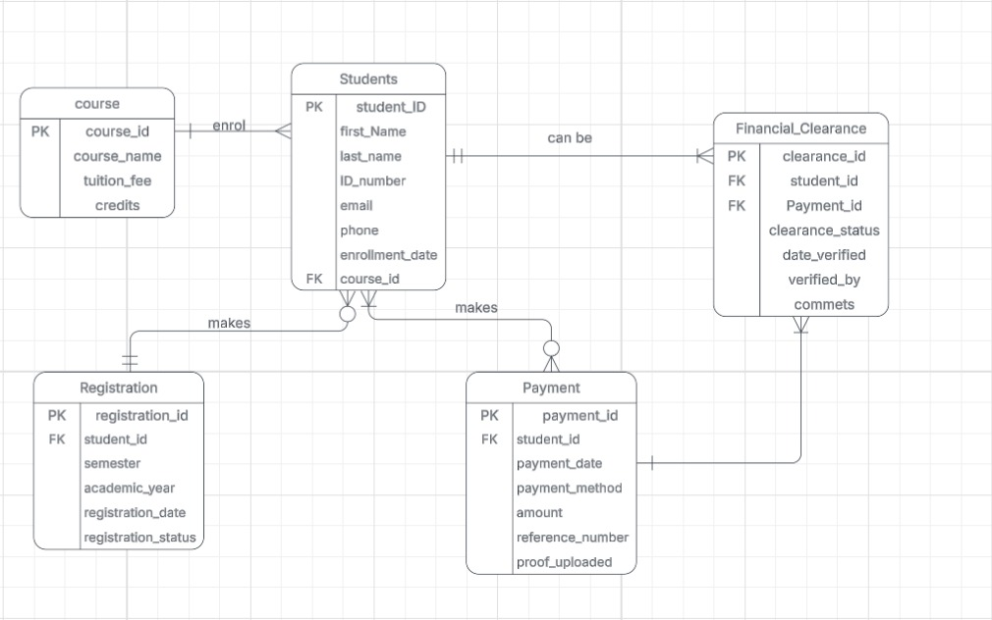
Figure 1 Entity Relationship Diagram
The EWC Registration database is normalised to Third Normal Form. Each entity stores information about a single business object, duplicate data is eliminated, and foreign keys maintain relationships between tables. This improves data integrity, reduces redundancy, and ensures consistent student, payment, clearance, and registration information.

5. DATABASE IMPLEMENTATION

5.1. DATABASE CREATION
USE master;
GO
CREATE DATABASE EWC_RegistrationDB;
GO
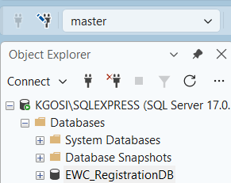
Figure 2 Data Base Creation

5.2 TABLE CREATION AND DATA INSERTION

Table Courses
USE EWC_RegistrationDB;
GO
CREATE TABLE dbo.courses (
course_id INT IDENTITY(1,1) PRIMARY KEY,
course_name VARCHAR(100) NOT NULL UNIQUE,
tuition_fee DECIMAL(10,2) NOT NULL,
credits VARCHAR(10) NOT NULL
);
GO

INSERT INTO dbo.courses (course_name, tuition_fee, credits) VALUES
('National Certificate: Engineering Studies', 18500.00, 'N6'),
('National Certificate: Business Studies', 15500.00, 'N6'),
('National Certificate: Information Technology', 17000.00, 'L4'),
('National Certificate: Hospitality', 14500.00, 'L4'),
('National Certificate: Office Administration', 13500.00, 'L4');
GO
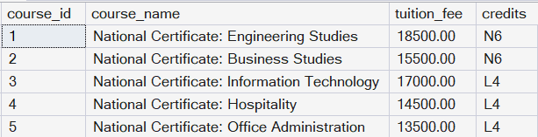
Figure 3 Course tbl

Table Students
CREATE TABLE dbo.students (
student_id INT IDENTITY(1,1) PRIMARY KEY,
first_name VARCHAR(50) NOT NULL,
last_name VARCHAR(50) NOT NULL,
id_number VARCHAR(13) NOT NULL UNIQUE,
email VARCHAR(100) NULL,
phone VARCHAR(20) NULL,
course_id INT NOT NULL,
enrolment_date DATE NOT NULL,
CONSTRAINT FK_students_courses FOREIGN KEY (course_id) REFERENCES dbo.courses(course_id)
);
GO

INSERT INTO dbo.students (first_name, last_name, id_number, email, phone, course_id, enrolment_date) VALUES
('Lerato', 'Khumalo', '0501015800081', 'lerato.k@student.ewc.ac.za', '0821234567', 1, '2026-01-15'),
('Kagiso', 'Molefe', '0403125800082', 'kagiso.m@student.ewc.ac.za', '0821234568', 2, '2026-01-15'),
('Naledi', 'Sithole', '0507225800083', 'naledi.s@student.ewc.ac.za', '0821234569', 3, '2026-01-16'),
('Tumelo', 'Mokoena', '0412095800084', 'tumelo.m@student.ewc.ac.za', '0821234570', 1, '2026-01-16'),
('Boitumelo', 'Radebe', '0509305800085', 'boitumelo.r@student.ewc.ac.za', '0821234571', 2, '2026-01-17'),
('Katlego', 'Ndlovu', '0411175800086', 'katlego.n@student.ewc.ac.za', '0821234572', 4, '2026-01-17'),
('Palesa', 'Mthembu', '0502285800087', 'palesa.m@student.ewc.ac.za', '0821234573', 1, '2026-01-18'),
('Onalenna', 'Kgosi', '0406145800093', 'onalenna.k@student.ewc.ac.za', '0821234579', 3, '2026-01-18'),
('Masixole', 'Thebe', '0508085800094', 'masixole.t@student.ewc.ac.za', '0821234580', 5, '2026-01-19'),
('Tshepo', 'Tsotetsi', '0501195800095', 'tshepo.t@student.ewc.ac.za', '0821234581', 2, '2026-01-19'),
('Ayanda', 'Mokoele', '0503035800096', 'ayanda.mo@student.ewc.ac.za', '0821234582', 4, '2026-01-20'),
('Luyanda', 'Magagula', '0407255800097', 'luyanda.m@student.ewc.ac.za', '0821234583', 5, '2026-01-20'),
('Thandeka', 'Zulu', '0502155800098', 'thandeka.z@student.ewc.ac.za', '0821234584', 4, '2026-01-21');
GO
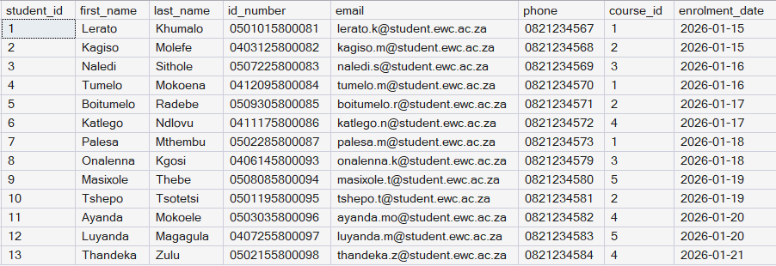
Figure 4 Student tbl

Table payments
CREATE TABLE dbo.payments (
payment_id INT IDENTITY(1,1) PRIMARY KEY,
student_id INT NOT NULL,
amount DECIMAL(10,2) NOT NULL,
payment_date DATE NOT NULL,
payment_method VARCHAR(30) NOT NULL,
reference_number VARCHAR(30) NOT NULL UNIQUE,
proof_uploaded BIT NOT NULL DEFAULT 0,
CONSTRAINT FK_payments_students FOREIGN KEY (student_id) REFERENCES dbo.students(student_id),
CONSTRAINT CK_payments_method CHECK (payment_method IN ('EFT', 'Cash', 'Card', 'NSFAS Disbursement', 'Bursary'))
);
GO

INSERT INTO dbo.payments (student_id, amount, payment_date, payment_method, reference_number, proof_uploaded) VALUES
(1, 1200.00, '2026-01-18', 'NSFAS Disbursement', 'PMT-1001', 1),
(1, 18500.00, '2026-02-10', 'NSFAS Disbursement', 'PMT-1002', 1),
(2, 1000.00, '2026-01-19', 'NSFAS Disbursement', 'PMT-1003', 1),
(3, 1200.00, '2026-01-19', 'EFT', 'PMT-1004', 1),
(4, 1200.00, '2026-01-20', 'Cash', 'PMT-1005', 0),
(5, 1000.00, '2026-01-21', 'NSFAS Disbursement', 'PMT-1006', 1),
(6, 900.00, '2026-01-21', 'Bursary', 'PMT-1007', 1),
(7, 1200.00, '2026-01-22', 'NSFAS Disbursement', 'PMT-1008', 1),
(8, 1200.00, '2026-01-22', 'EFT', 'PMT-1009', 1),
(9, 900.00, '2026-01-23', 'NSFAS Disbursement', 'PMT-1010', 1),
(10, 1000.00, '2026-01-23', 'Card', 'PMT-1011', 1),
(11, 900.00, '2026-01-24', 'EFT', 'PMT-1012', 1),
(12, 900.00, '2026-01-24', 'NSFAS Disbursement', 'PMT-1013', 1),
(2, 15500.00, '2026-02-12', 'NSFAS Disbursement', 'PMT-1014', 1),
(3, 8500.00, '2026-02-15', 'EFT', 'PMT-1015', 1),
(13, 900.00, '2026-01-25', 'EFT', 'PMT-1017', 1);
GO
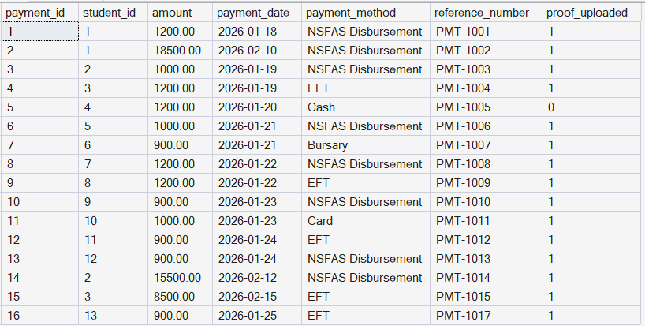
Figure 5 Payment tbl

Table financial_clearence
CREATE TABLE dbo.financial_clearance (
clearance_id INT IDENTITY(1,1) PRIMARY KEY,
student_id INT NOT NULL,
payment_id INT NULL,
clearance_status VARCHAR(20) NOT NULL,
date_verified DATE NULL,
verified_by VARCHAR(50) NOT NULL,
comments VARCHAR(255) NULL,
CONSTRAINT FK_clearance_students FOREIGN KEY (student_id) REFERENCES dbo.students(student_id),
CONSTRAINT FK_clearance_payments FOREIGN KEY (payment_id) REFERENCES dbo.payments(payment_id),
CONSTRAINT CK_clearance_status CHECK (clearance_status IN ('Pending', 'Cleared', 'Rejected'))
);
GO

INSERT INTO dbo.financial_clearance (student_id, payment_id, clearance_status, date_verified, verified_by, comments) VALUES
(1, 1, 'Cleared', '2026-01-19', 'Finance Officer - Nomvula Dube', 'Proof of payment verified.'),
(2, 3, 'Cleared', '2026-01-20', 'Finance Officer - Nomvula Dube', 'Proof of payment verified.'),
(3, 4, 'Cleared', '2026-01-20', 'Finance Officer - Sipho Mahlangu', 'Proof of payment verified.'),
(4, 5, 'Pending', NULL, 'Finance Officer - Sipho Mahlangu', 'Awaiting valid proof of payment upload.'),
(5, 6, 'Cleared', '2026-01-22', 'Finance Officer - Nomvula Dube', 'Proof of payment verified.'),
(6, 7, 'Cleared', '2026-01-22', 'Finance Officer - Sipho Mahlangu', 'Bursary payment confirmed.'),
(7, 8, 'Cleared', '2026-01-23', 'Finance Officer - Nomvula Dube', 'Proof of payment verified.'),
(8, 9, 'Rejected', '2026-01-23', 'Finance Officer - Sipho Mahlangu', 'Reference number did not match bank statement.'),
(9, 10, 'Cleared', '2026-01-24', 'Finance Officer - Nomvula Dube', 'Proof of payment verified.'),
(10, 11, 'Cleared', '2026-01-24', 'Finance Officer - Sipho Mahlangu', 'Proof of payment verified.'),
(11, 12, 'Cleared', '2026-01-25', 'Finance Officer - Nomvula Dube', 'Proof of payment verified.'),
(12, 13, 'Cleared', '2026-01-25', 'Finance Officer - Sipho Mahlangu', 'Proof of payment verified.'),
(13, 16, 'Cleared', '2026-01-27', 'Finance Officer - Nomvula Dube', 'Proof of payment verified. Not yet registered - flagged as at-risk.');
GO
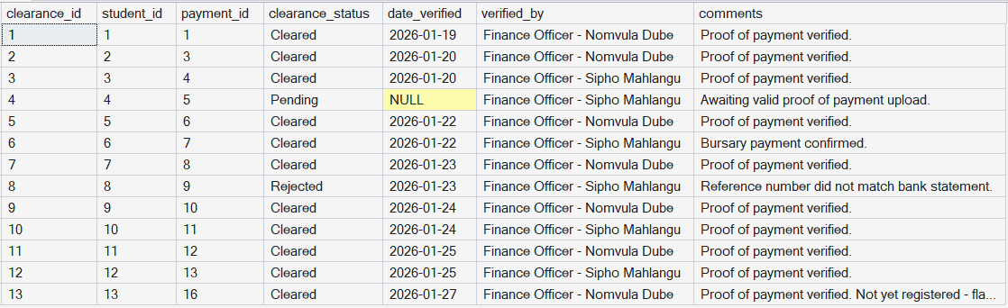
Figure 6 Financial Clearence

Table Registration
CREATE TABLE dbo.registrations (
registration_id INT IDENTITY(1,1) PRIMARY KEY,
student_id INT NOT NULL,
semester VARCHAR(20) NOT NULL,
academic_year SMALLINT NOT NULL,
registration_date DATE NOT NULL,
registration_status VARCHAR(20) NOT NULL,
CONSTRAINT FK_registrations_students FOREIGN KEY (student_id) REFERENCES dbo.students(student_id),
CONSTRAINT CK_registrations_status CHECK (registration_status IN ('Registered', 'Provisional', 'De-registered', 'Cancelled'))
);
GO

INSERT INTO dbo.registrations (student_id, semester, academic_year, registration_date, registration_status) VALUES
(1, 'Semester 1', 2026, '2026-01-20', 'Registered'),
(2, 'Semester 1', 2026, '2026-01-21', 'Registered'),
(3, 'Semester 1', 2026, '2026-01-21', 'Registered'),
(5, 'Semester 1', 2026, '2026-01-23', 'Registered'),
(6, 'Semester 1', 2026, '2026-01-23', 'Registered'),
(7, 'Semester 1', 2026, '2026-01-24', 'Registered'),
(9, 'Semester 1', 2026, '2026-01-25', 'Registered'),
(10, 'Semester 1', 2026, '2026-01-25', 'Provisional'),
(11, 'Semester 1', 2026, '2026-01-26', 'Registered'),
(12, 'Semester 1', 2026, '2026-01-26', 'Registered');
GO
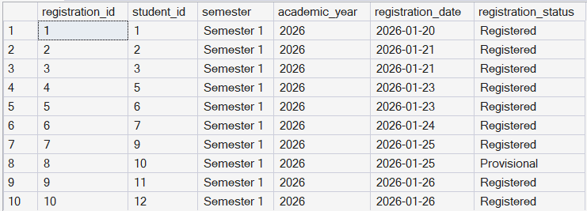
Figure 7 Registration tbl

6. SQL Queries and Decision Support

6.1 Transaction Processing Queries

A1. Student Lookup
SELECT s.student_id, s.first_name, s.last_name, s.id_number, c.course_name, s.enrolment_date,
ISNULL(pay.total_amount_paid, 0) AS total_amount_paid, r.registration_status
FROM students s
JOIN courses c ON s.course_id = c.course_id
LEFT JOIN (
SELECT student_id, SUM(amount) AS total_amount_paid
FROM payments
GROUP BY student_id
) pay ON pay.student_id = s.student_id
LEFT JOIN registrations r ON r.student_id = s.student_id
WHERE s.last_name = 'Molefe';
GO
Figure 8 Student Lookup
We want to find a student by surname and see their course, enrolment, date, total amount paid so far, and current registration status.

A2. Student Lookup
SELECT s.first_name, s.last_name, p.reference_number, p.amount, fc.clearance_status, fc.date_verified,
fc.verified_by
FROM financial_clearance fc
JOIN students s ON fc.student_id = s.student_id
JOIN payments p ON fc.payment_id = p.payment_id
where clearance_status = 'Cleared'
ORDER BY fc.clearance_status, s.last_name;
GO
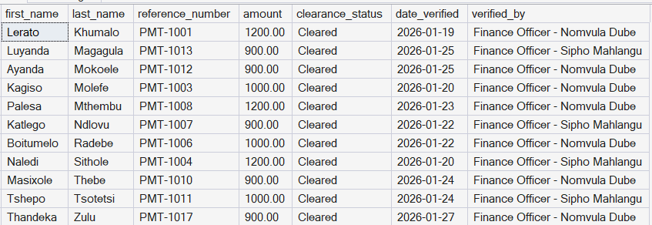
Figure 9 Student Lookup
We want to see the clearance status and verification details for every payment, so Finance can track which are cleared, pending, or rejected without checking each one individually

A3. Course Availability
SELECT c.course_id, c.course_name, c.tuition_fee,
COALESCE(COUNT(DISTINCT r.student_id), 0) AS registered_students
FROM dbo.courses c
LEFT JOIN dbo.students s ON s.course_id = c.course_id
LEFT JOIN dbo.registrations r
ON r.student_id = s.student_id
AND r.registration_status = 'Registered'
GROUP BY c.course_id, c.course_name, c.tuition_fee
ORDER BY c.course_name;
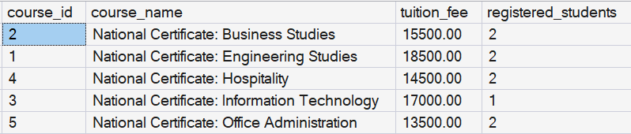
Figure 10 Course Availability
We want to see the courses that are available in the institution, the amount payable, and how many students are registered in each course so far.

A3. Registered Students
SELECT s.first_name, s.last_name, c.course_name, r.academic_year, r.registration_date,
c.tuition_fee AS registration_fee,
r.registration_status
FROM registrations r
JOIN students s ON r.student_id = s.student_id
JOIN courses c ON s.course_id = c.course_id
WHERE r.registration_status = 'Registered'
ORDER BY r.registration_date;
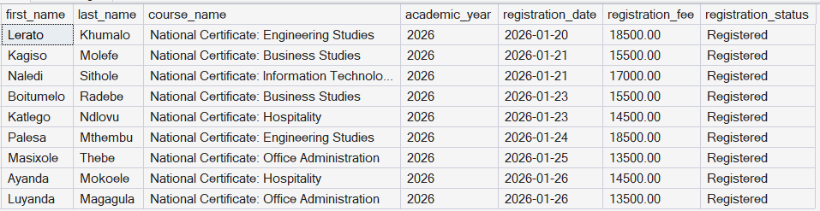
Figure 11 Registered Students
We want to see all students who are registered and their courses, the date they registered on, and the registration fee amount they have paid.

B. MANAGEMENT REPORTS

B1. Daily/Monthly clearance summary
SELECT
clearance_status,
COUNT(*) AS number_of_cases
FROM financial_clearance
GROUP BY clearance_status
ORDER BY number_of_cases DESC;
GO
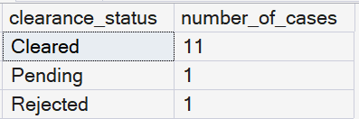
Figure 12 Daily /monthly clearance summary
We want to see how many students were Cleared, Pending, or Rejected overall so that Finance management can gauge processing progress.

B2. Monthly registration summary
SELECT
CONVERT(CHAR(7), registration_date, 120) AS registration_month,
COUNT(*) AS number_of_registrations
FROM registrations
GROUP BY CONVERT(CHAR(7), registration_date, 120)
ORDER BY registration_month;
GO
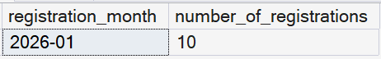
Figure 13 Monthly registration summary
We want to see how many students registered each month to track registration volume over time.

B3 Outstanding clearance report
SELECT
verified_by,
clearance_status,
COUNT(*) AS number_of_cases
FROM financial_clearance
WHERE clearance_status IN ('Pending', 'Rejected')
GROUP BY verified_by, clearance_status
HAVING COUNT(*) >= 1
ORDER BY number_of_cases DESC;
GO
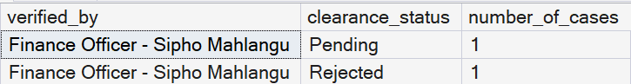
Figure 14 Outstanding Clearance report
We want to see how many Pending or Rejected cases each Finance officer is holding, so management knows where follow-up is needed.

B4. Payment collection summary by method

SELECT
payment_method,
COUNT(*) AS number_of_payments,
SUM(amount) AS total_collected
FROM payments
GROUP BY payment_method
ORDER BY total_collected DESC;
GO
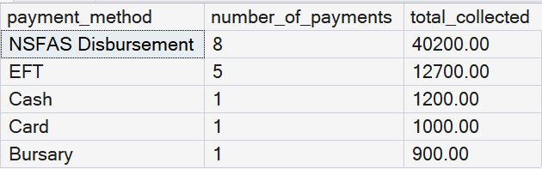
Figure 15 Payment collection summary by method
We want to see the total value and number of payments collected through each payment method.

B5. Monthly revenue analysis
SELECT
CONVERT(CHAR(7), payment_date, 120) AS payment_month,
SUM(amount) AS total_revenue
FROM payments
GROUP BY CONVERT(CHAR(7), payment_date, 120)
ORDER BY payment_month;
GO
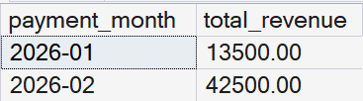
Figure 16 Monthly revenue analysis
We want to see total revenue collected per month for financial planning and reporting.

B6. Course enrolment summary
SELECT
c.course_name,
c.credits,
COUNT(s.student_id) AS number_of_students,
SUM(c.tuition_fee) AS potential_tuition_value
FROM courses c
JOIN students s ON c.course_id = s.course_id
GROUP BY c.course_name, c.credits
ORDER BY number_of_students DESC;
GO
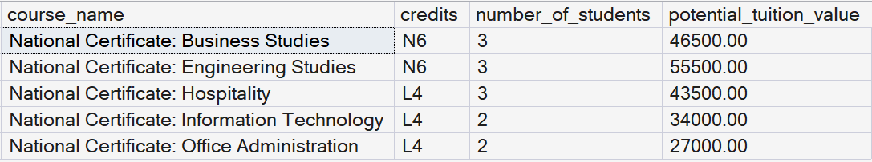
Figure 17 Course enrolment summary
We want to see how many students are enrolled in each course, along with its credit value and potential tuition revenue, to identify the most in-demand courses.

C. DECISION SUPPORT QUERIES

C1. Registration trend

SELECT
CAST(DATEADD(week, DATEDIFF(week, 0, registration_date), 0) AS date) AS registration_week_start,
COUNT(*) AS registrations_this_week
FROM registrations
GROUP BY CAST(DATEADD(week, DATEDIFF(week, 0, registration_date), 0) AS date)
ORDER BY registration_week_start;
GO
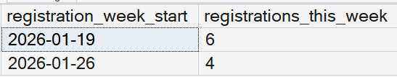
Figure 18 Registration trend
We want to see how registrations are trending week by week to support planning for future intakes.

C2. Aggregated payment statistics
SELECT
payment_method,
COUNT(*) AS number_of_payments,
AVG(amount) AS average_amount,
MIN(amount) AS smallest_payment,
MAX(amount) AS largest_payment
FROM payments
GROUP BY payment_method
ORDER BY average_amount DESC;
GO
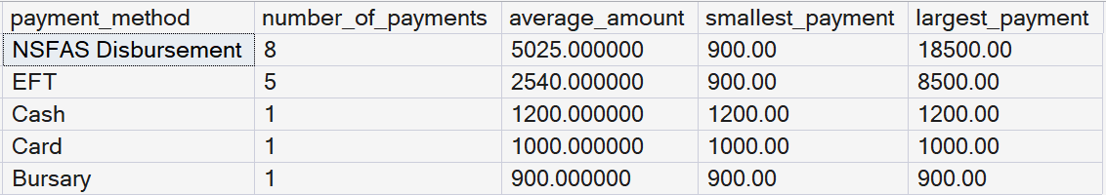
Figure 19 Aggregated payment statistics
We want to see the average, smallest, and largest payment amount for each payment method.

C3. Forecasting indicator - enrolment growth by week
SELECT
CAST(DATEADD(week, DATEDIFF(week, 0, enrolment_date), 0) AS date) AS enrolment_week_start,
COUNT(*) AS new_enrolments
FROM students
GROUP BY CAST(DATEADD(week, DATEDIFF(week, 0, enrolment_date), 0) AS date)
ORDER BY enrolment_week_start;
GO
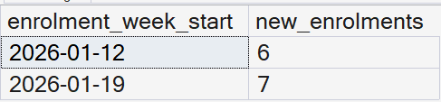
Figure 20 Forecasting indicator - enrolment growth by week
We want to see how many students enrolled each week to spot patterns that help predict future intake volume.

C4. Bottleneck identification
SELECT
fc.verified_by,
COUNT(*) AS payments_cleared,
AVG(DATEDIFF(day, p.payment_date, fc.date_verified)) AS avg_days_to_clear
FROM financial_clearance fc
JOIN payments p ON fc.payment_id = p.payment_id
WHERE fc.clearance_status = 'Cleared'
GROUP BY fc.verified_by
HAVING COUNT(*) >= 1
ORDER BY avg_days_to_clear DESC;
GO
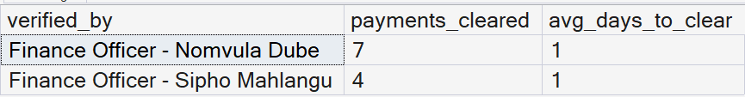
Figure 21 Bottleneck identification
We want to see, on average, how many days it takes each Finance officer to clear a payment, so management can identify where clearance is slowest and needs more staff or attention.

C5. At-risk students report
SELECT s.student_id, s.first_name, s.last_name, fc.clearance_status, fc.date_verified, r.registration_status
FROM students s
JOIN financial_clearance fc ON fc.student_id = s.student_id
LEFT JOIN registrations r ON r.student_id = s.student_id
WHERE fc.clearance_status = 'Cleared' AND r.registration_id IS NULL
ORDER BY fc.date_verified;
GO
Figure 22 At-risk students report
We want to find students who have been financially cleared but have not yet registered, so Registry can follow up with them before the registration deadline.

7. SYSTEM EVALUATION AND RECOMMENDATIONS

BENEFITS
The proposed Online Student Registration and Financial Clearance System will remove the need for students to come to campus to register, since proof of payment, financial clearance, and module registration will all be completed through one online process.
It will integrate the Finance Department and Registration Office into a single digital workflow, so a student's financial and registration status can be checked in real time instead of moving between departments.
Students will no longer stand in long queues or must return the next day if a department is closed or busy, because clearance and registration will happen electronically.
Finance officers will verify proof of payment digitally instead of checking paper slips one by one, and registration clerks will register students electronically once they are unblocked. This will reduce their workload and cut down on repetitive manual checking.
The system will give management, auditors and funders such as NSFAS real-time, accurate reports on clearance and registration progress, supporting the MIS and DSS reporting that the current manual process cannot provide.
A single digital record for each student's payments, clearance and registration will reduce the inconsistencies that currently occur because Finance and Registration keep separate records.

LIMITATIONS
The system depends on a reliable network and internet connection at the Germiston campus, and later at the other five campuses. If the network goes down, staff may have to fall back on the manual process temporarily.
The system still depends on accurate data being entered, whether that is a student uploading proof of payment or a finance officer capturing a verification. Incorrect information entered at any stage will still affect the accuracy of the system.
Finance officers, registration clerks and other affected staff will need training before they can use the new online clearance and registration workflow confidently.
Not all students may have reliable internet access or a suitable device to upload documents and register online, which could disadvantage some students during the transition to the new system.
Special or disputed cases, such as partial NSFAS payments or rejected proof of payment, will still need to be reviewed manually by a finance officer or registration clerk; the system cannot fully automate these exceptions.

RISKS
There is a risk of errors when existing student, payment, and registration records are migrated from spreadsheets and paper files into the new database.
The system could come under heavy load and slow down or fail during peak registration periods, when large numbers of students are uploading proof of payment and registering at the same time.
Staff may become over-reliant on the automated clearance process and fail to properly investigate payment problems, exceptions, or possible fraud.
If the system depends on third-party hosting or software, EWC's registration process becomes partly dependent on the reliability and security of that outside provider.
Because financial clearance and registration will run through one integrated system, a security breach or extended downtime could disrupt clearance and registration for the whole college, not just one department.

SECURITY CONSIDERATIONS
The system will store private student financial and academic information, including uploaded proof of payment, so strong security controls are essential.
Role-based access should ensure that students, finance officers, registration clerks, HODs, campus managers, and the system administrator can each only see and change the information relevant to their role.
The student portal should enforce strong authentication, since the current portal does not. This addresses one of the security weaknesses identified in the existing system.
Student information must be protected both when it is transmitted, for example during proof of payment uploads, and when it is stored in the database.
The system should keep a digital audit trail linking a payment to its financial clearance and then to the resulting registration, so staff can trace who approved what and when. This directly addresses the lack of a digital audit trail in the current manual process.
Regular security checks and access reviews should be carried out to prevent unauthorised access and to catch weaknesses before they can be exploited.

ETHICAL CONSIDERATIONS
The system must comply with South Africa's Protection of Personal Information Act (POPIA), and student data must be collected, stored, and used lawfully.
Students should be informed about how their financial and academic information is used within the system.
Access to student data should be limited to staff who need it to perform their role, in line with the role-based access approach described above.
The system must treat students fairly, particularly those with unusual payment situations, such as partial NSFAS payments; these students should not be unfairly blocked from registering by an automatic decision.
There must always be a way for a finance officer or registration clerk to review and correct special cases rather than leaving them entirely to automated processing.
Because the system depends on internet access and digital devices, EWC should consider how students without reliable connectivity are supported, so the new system does not create new inequalities among students.

FUTURE IMPROVEMENTS
Direct integration with the NSFAS platform so that bursary payments can be verified automatically instead of manually.
SMS or email notifications to keep students informed as their proof of payment, clearance, and registration status changes.
Rolling the system out to EWC's other five campuses once the Germiston pilot has proven successful.
A mobile-friendly or app version to make it easier for students to upload documents and register from a phone.
Expanding the Decision Support System with predictive analytics, for example, identifying students who have paid but not yet registered or forecasting registration bottlenecks before they occur.
Direct integration with banks or online payment gateways, so that proof of payment can eventually be confirmed automatically rather than uploaded and manually checked.

RECOMMENDATIONS FOR IMPLEMENTATION
EWC should introduce the system in stages, starting with a pilot at the Germiston campus before rolling it out to the other five campuses.
Finance officers, registration clerks and other affected staff should receive proper training before the system goes live.
Historical payment, clearance and registration records should be checked and cleaned before they are migrated into the new system, to reduce the risk of migration errors.
For an initial period, the manual and new online processes should run in parallel so that EWC can confirm the new system is accurate before the manual process is retired.
Role-based access controls and audit trails should be built into the system from the start rather than added later, so security and accountability are in place from day one.
A clear escalation process should be defined for disputed or exception cases, such as partial NSFAS payments, so students are not left without a way to resolve their registration.
EWC should continue to monitor the system after launch, carry out regular security reviews, and ensure ongoing compliance with DHET and POPIA requirements.

References
Laudon, K. C., & Laudon, J. P. (2022). Management Information Systems: Managing the Digital Firm (17th ed.). Pearson.
Department of Higher Education and Training. (2024). Technical and Vocational Education and Training (TVET) College Guidelines.
Republic of South Africa. (2013). Protection of Personal Information Act 4 of 2013 (POPIA).
South African Qualifications Authority. (2024). TVET and Higher Education Information Guidelines.
National Student Financial Aid Scheme. (2025). NSFAS Funding and Student Administration Guidelines.
.

